RegNo: 24RP03897
Names: TUYUBAHE Confiance

PHP Assignment

Insert Document:
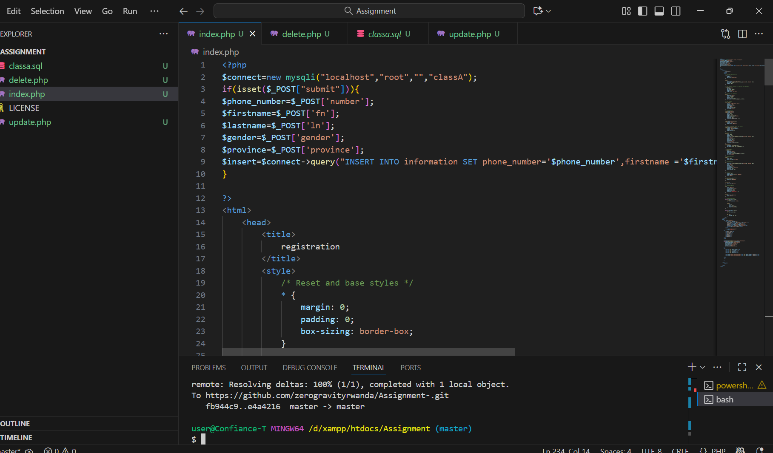
I have created both insert form and table that is used to display inserted data in the database at the same time so that my file can do both insert and retrieve of the data in the database I have also inserted connection first as I have to first make connection so that the files can be able to communicate with the database I have also inserted some css so that I have well designed page

Delete
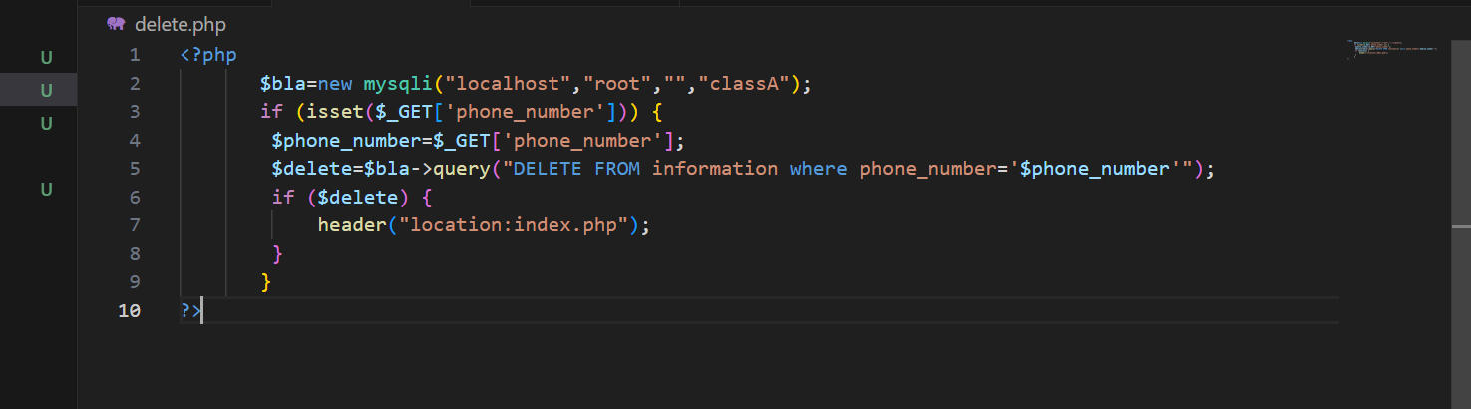
In delete I have used a grobal variable $_GET so that I can use it to monitor the phone number as unique identifier in my table so that I can use it to delete specific data when variable phone_number isset

Update
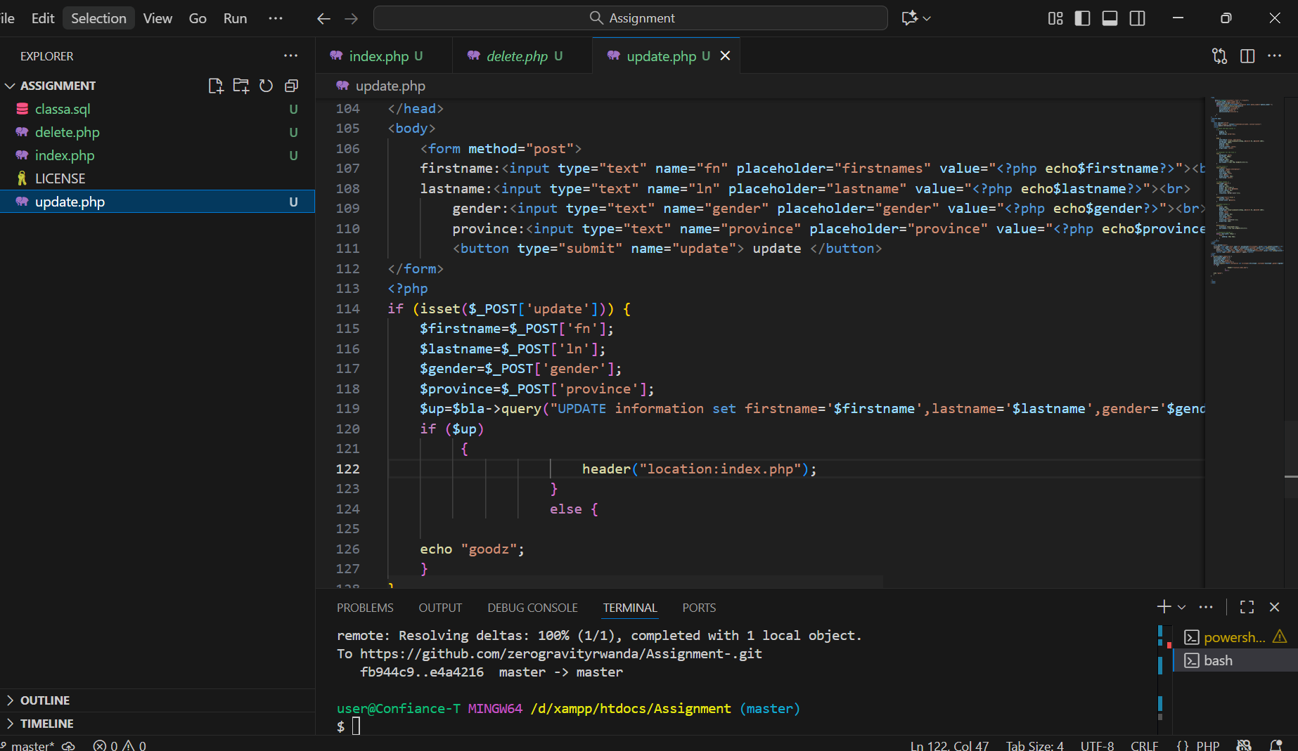
Here in update I have used also grobal variable $_GET so that also I can update specified data record

